# CS 255 System Design Document Template

This template lays out all the different sections that you need to complete for Project Two. Each section has guidance to prompt your thinking. You will need to continually reference the interview transcript as you work to make sure that you are addressing your client’s needs. There is no required length for the final document. Instead the goal is to complete each section based on what your client’s needs are. Remove this note when you are finished, and replace all bracketed text with the relevant information.

## UML Diagrams

### UML Use Case Diagram

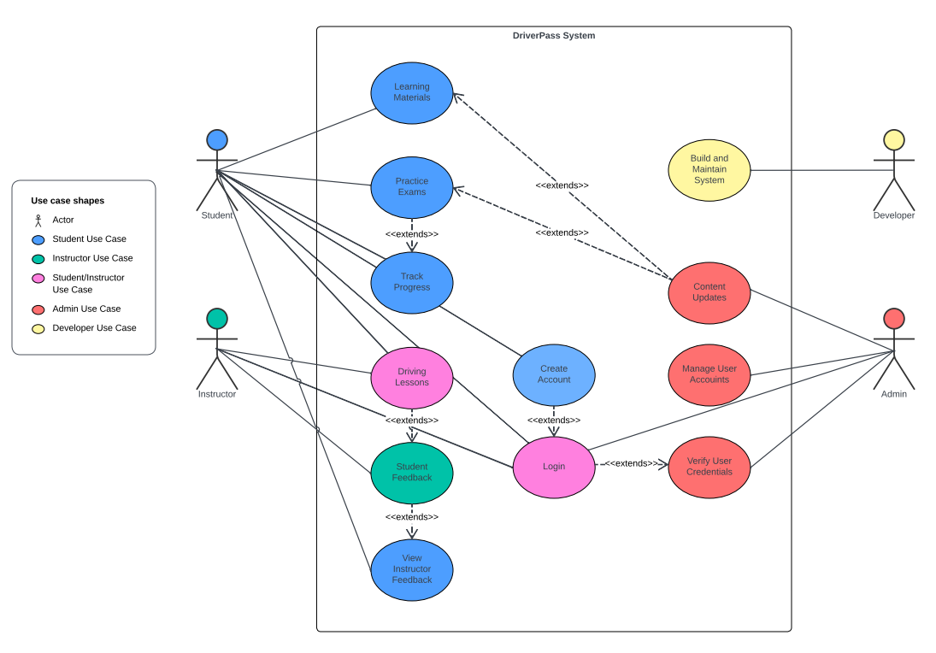

### UML Activity Diagrams

**

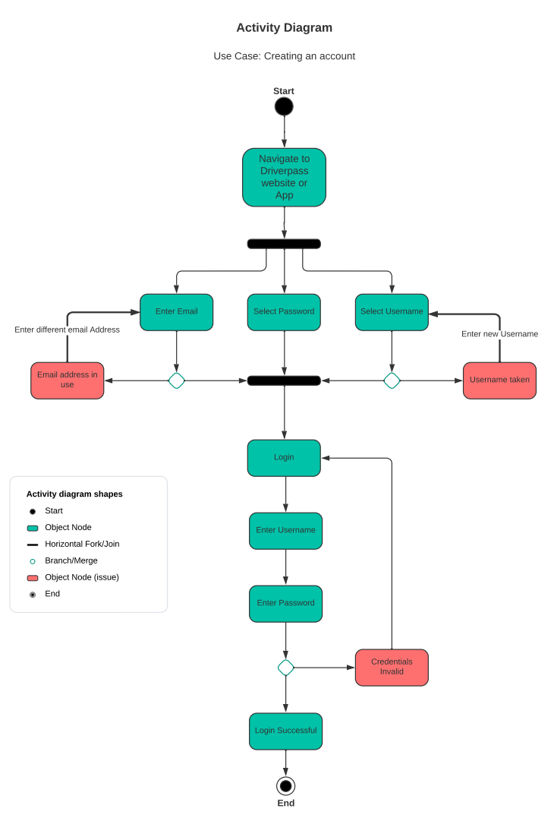

**

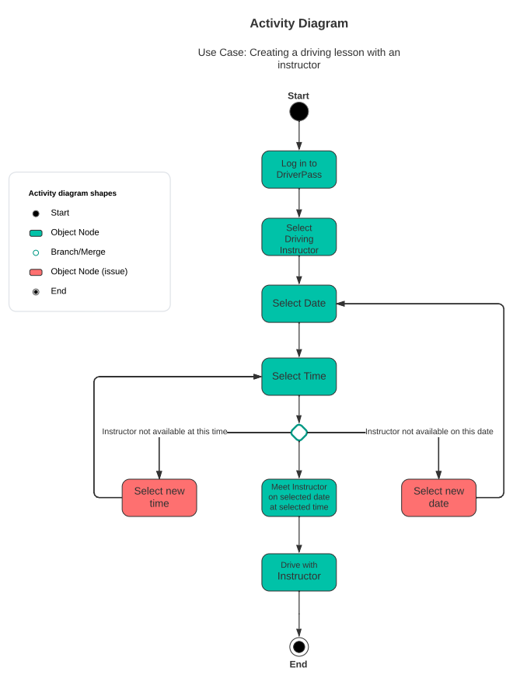

### UML Sequence Diagram

**

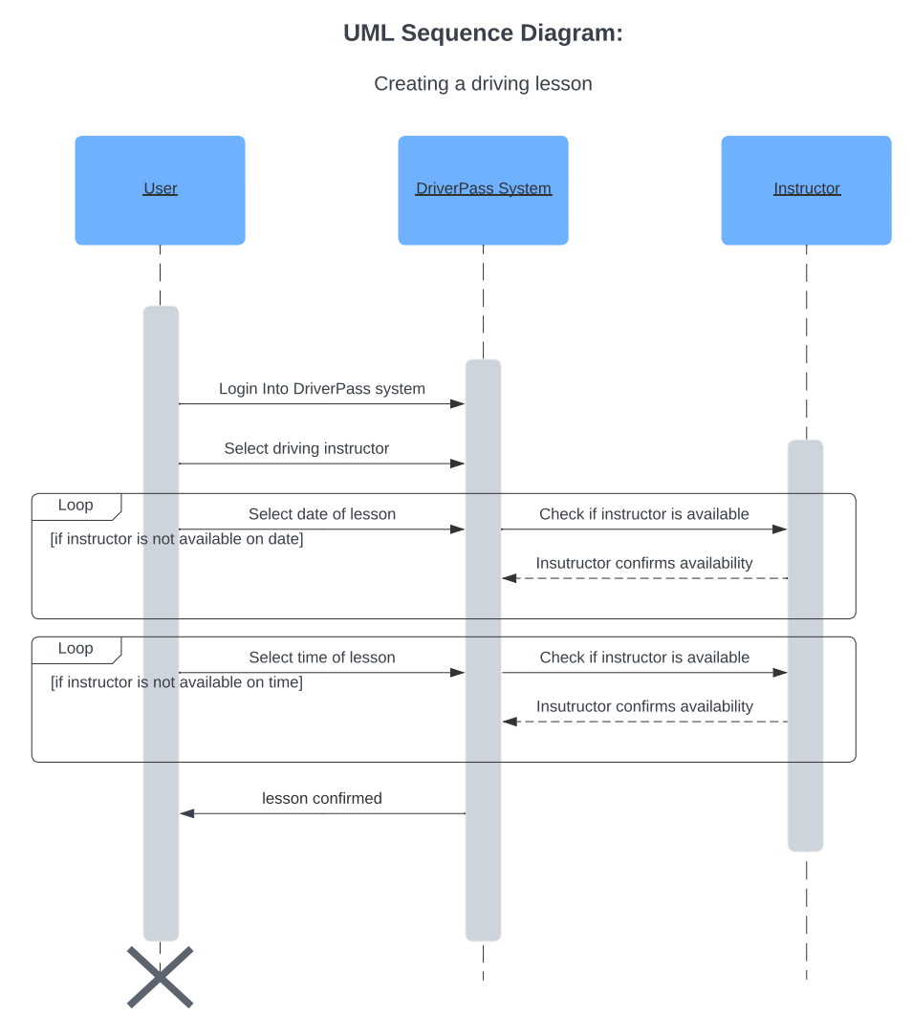

### UML Class Diagram

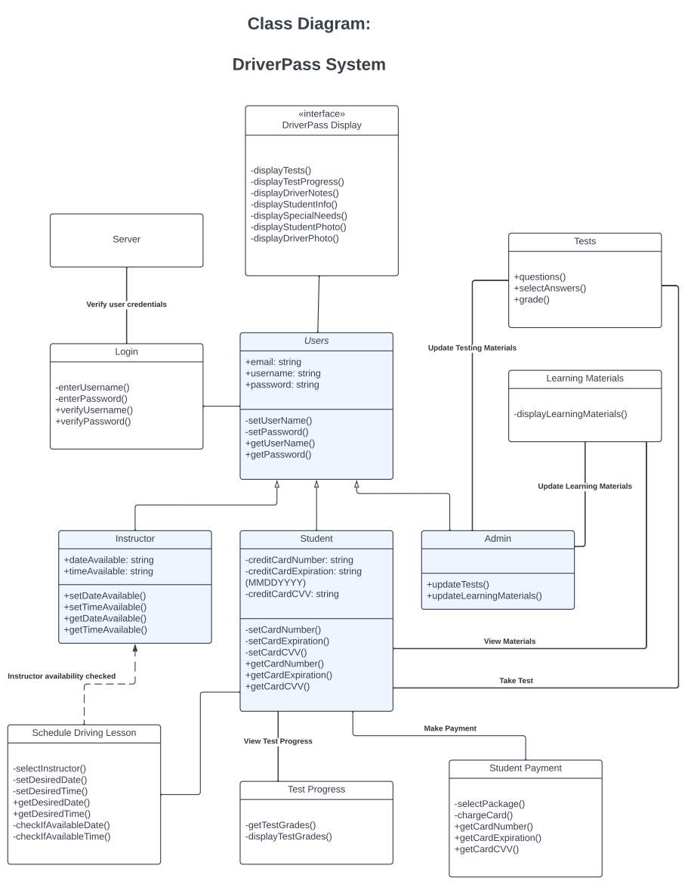

## Technical Requirements

One of the most important technical requirements is that the DriverPass system will need to be operational on both computers and mobile devices. This includes Windows and Apple Computers as well as iPhones and Androids. This will be no easy task, but the development team will need to work with HTML, apple iOS, and Android OS. To begin development the team will need to have computers that are capable of programming in these languages as well as running virtual machines for apple iOS, Android OS, and Mac OS, or Windows depending on the operating system of the computers used. The development team will need to use APIs to code in HMTL and choose an appropriate language to program for both apple iOS and Android OS. A server will be needed to run the system on. The server will house the system and the user database. This server will need to be secure as it will contain the personal information and credit card information of various users. It will also need to be able to run the system reliably with performance being of high importance.